GridTalk HTTP Backend Connector (HTTPBC) Design

CONFIDENTIALITY & COPYRIGHT

This document contains information confidential to the project. Any form of reproduction, transmission for use of this document or its contents is not permitted without prior written approval from GridNode Pte Ltd. All rights are reserved.

VERSION HISTORY

SN | Date | Author | Version | Description
1 | 20070723 | Soklay | 1.0 | Initial Draft

CONTENT

1 Introduction 3
1.1 Organization 3
2 Component Model 4
2.1 GTAS-Workflow Engine 4
2.2 GTHB 4
2.3 TxInQueue 4
2.4 Backend-HttpClient 4
2.5 ISHC 5
2.6 ISHB 5
2.7 Backend-HttpServer 5
2.8 GTAS-Document Mgr 5
3 Logical Model 6
3.1 Sequence Diagrams 6
3.1.1 Push Transactions To Backend 6
3.1.2 Receive Transactions from Backend 7
3.1.3 Deliver Pending Transactions to Backend 7
3.1.4 Deliver Pending Transactions to GridTalk 9
3.1.5 Sending Event Notifications 10
3.2 Class Diagrams 11
3.2.1 GTHB 11
3.2.2 ISHC 11
3.2.3 ISHB 12
3.3 Class / Package Descriptions 15
3.3.1 Module: HTTPBC 15
3.3.2 Module: UTIL 17
3.3.3 Module: GTAS.DOCUMENT 17
4 Interface Model 18
4.1 Outgoing Connections from HTTPBC 18
4.2 Incoming Connections to HTTPBC 19

Introduction
The purpose of this documentation is to describe the design model of the GridTalk HTTPBC module.

The HTTPBC module serves as an HTTP-based adapter for backend systems to send and receive transactions from trading partners via GridTalk.

Organization
The rest of this document is organized into the following sections:

- Section 2 describes the component model
- Section 3 describes the logical model
- Section 4 describes the interface model

Component Model

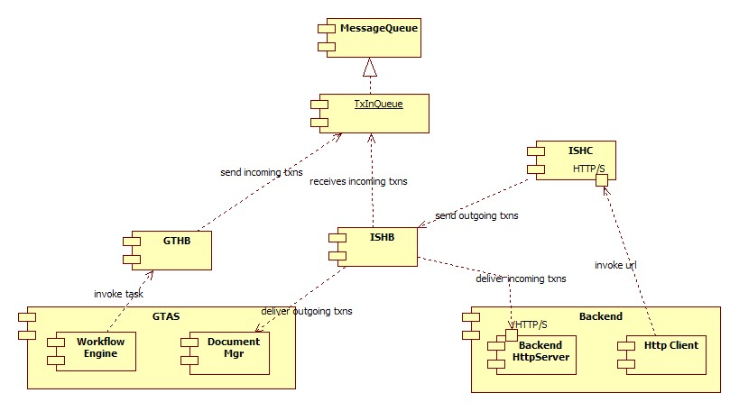
Figure 1: HTTPBC Component Model

The diagram above shows the components involved in the workings of HTTPBC. The following sub-sections describe each component shown.

GTAS-Workflow Engine
The workflow engine invokes the GTHB as part of its task specified in the particular workflow instance that it is executing. The task should be invoked when a transaction is received from the trading partner and the format is ready for the backend system to receive it.

GTHB
This component acts as the interface between GTAS and HTTPBC. It is a very lightweight component that just sends the incoming transaction on to a designated queue.

TxInQueue
This is a message queue whereby incoming transactions are queued up for handling in sequence by the ISHB component.

Backend-HttpClient
This is an arbitrary HTTP-based client that is capable of invoking the HTTP URL of HTTPBC, sending in the transactions that need to be delivered to the trading partner. See Section 4.2 for details on the HTTP Request requirements.

ISHC
This component acts as the interface between HTTPBC and backend system. It handles the HTTP request from the backend system, and calls on ISHB to handle the transaction.

ISHB
This component performs the following tasks:
- Receives incoming & outgoing transactions from GTHB and ISHC respectively, and saves the transactions in the transaction table
- Process the transactions in the transaction table in order of received time
- Delivers the incoming transactions to the backend system, and delivers the outgoing transactions to GTAS

Backend-HttpServer
This is an arbitrary HTTP Server that is capable of receiving HTTP requests which are packaged in a pre-defined format. See Section 4.1 for details on the HTTP request requirements.

GTAS-Document Mgr
The Document Mgr performs an import of the outgoing transactions received from ISHB.

Logical Model

Sequence Diagrams

Push Transactions To Backend
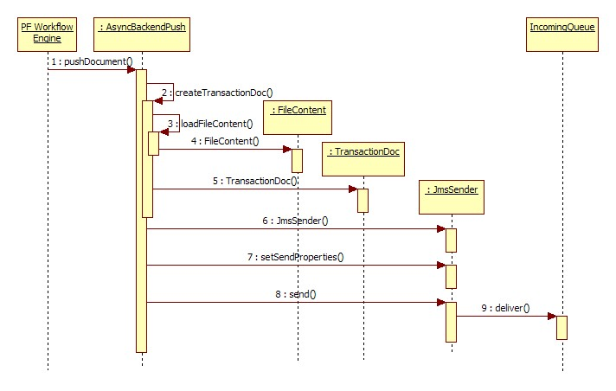

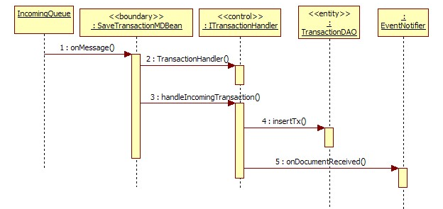

Receive Transactions from Backend
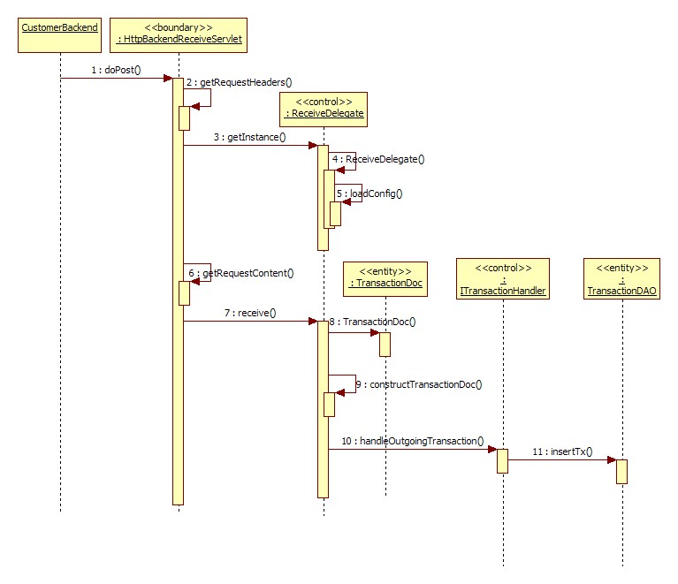

Deliver Pending Transactions to Backend
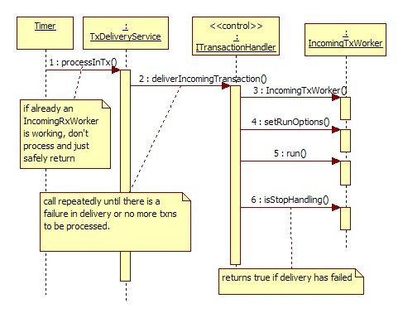
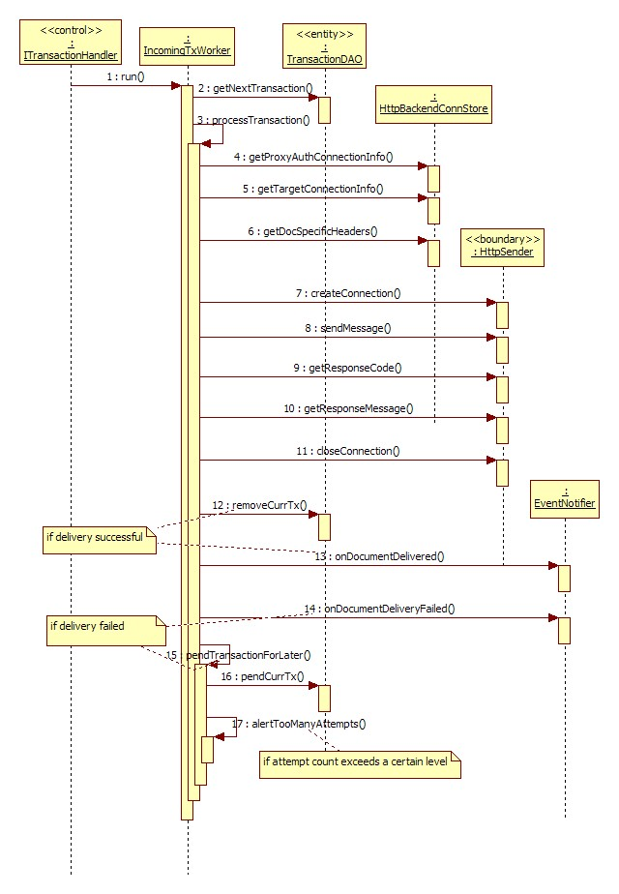

Deliver Pending Transactions to GridTalk
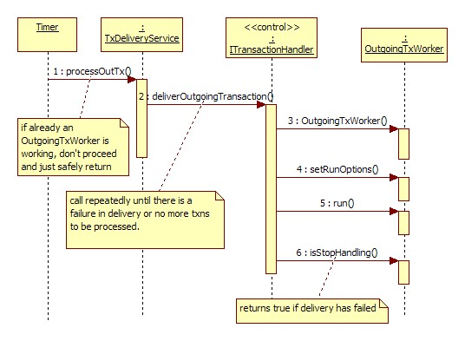
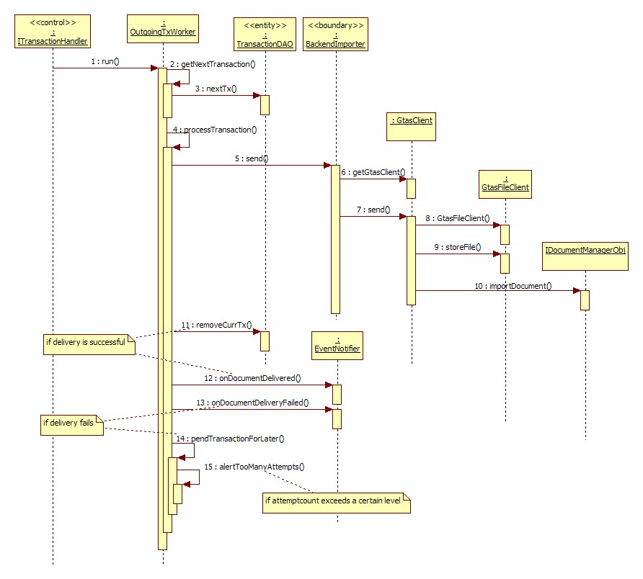

Sending Event Notifications
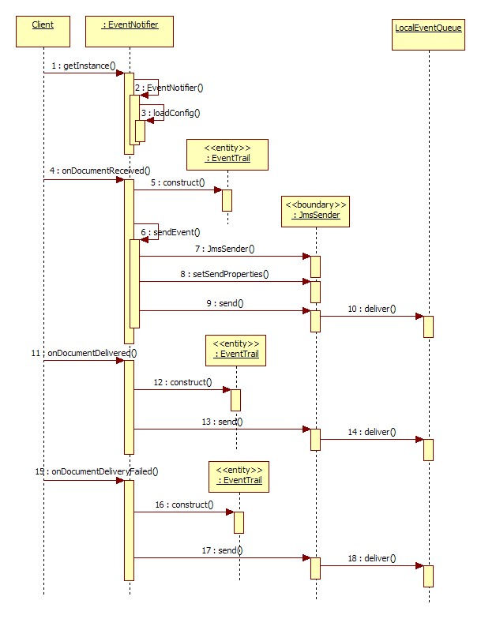

Class Diagrams

GTHB
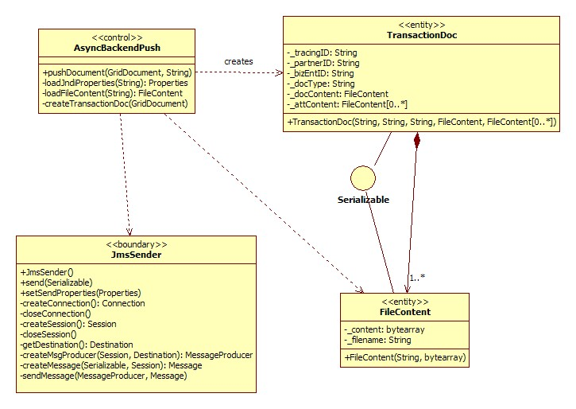
Figure 2: Class Participants in GTHB

ISHC
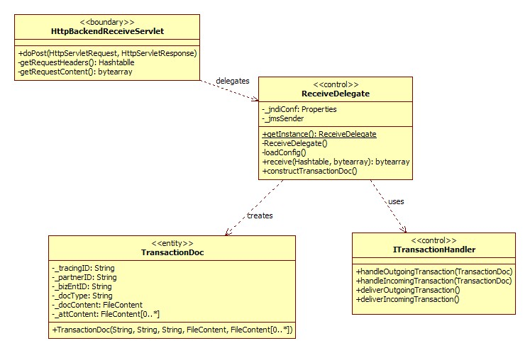
Figure 3: Class Participants in ISHC

ISHB
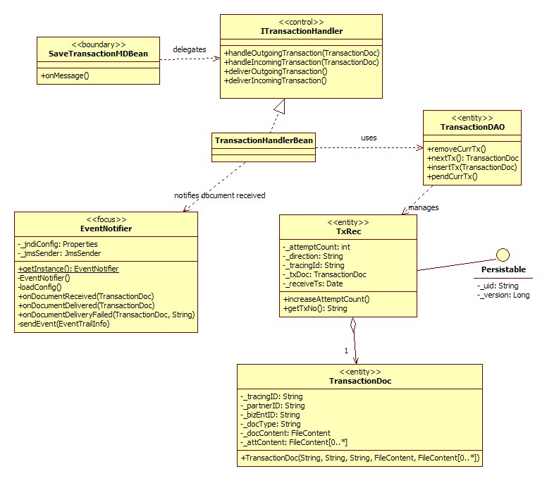
Figure 4: Class Participants in ISHB for Transaction Handling

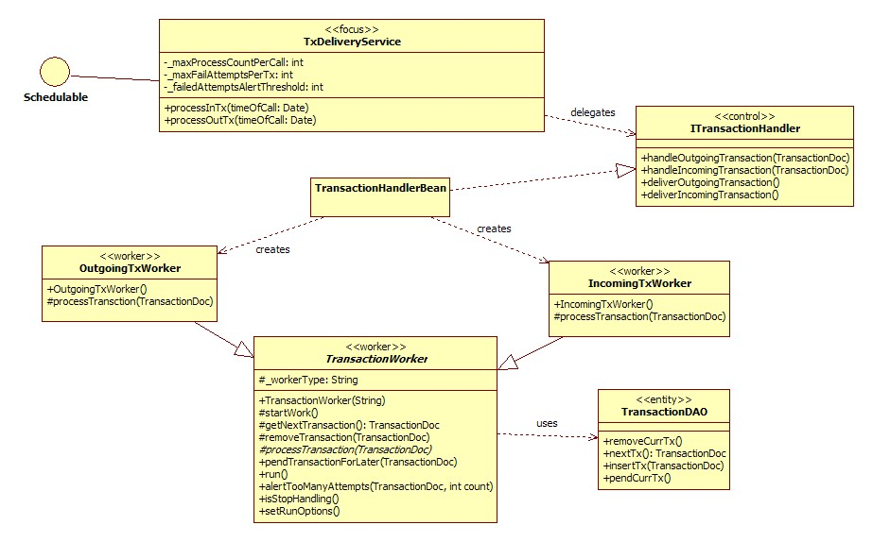
Figure 5: Class Participants in ISHB for Transaction Delivery

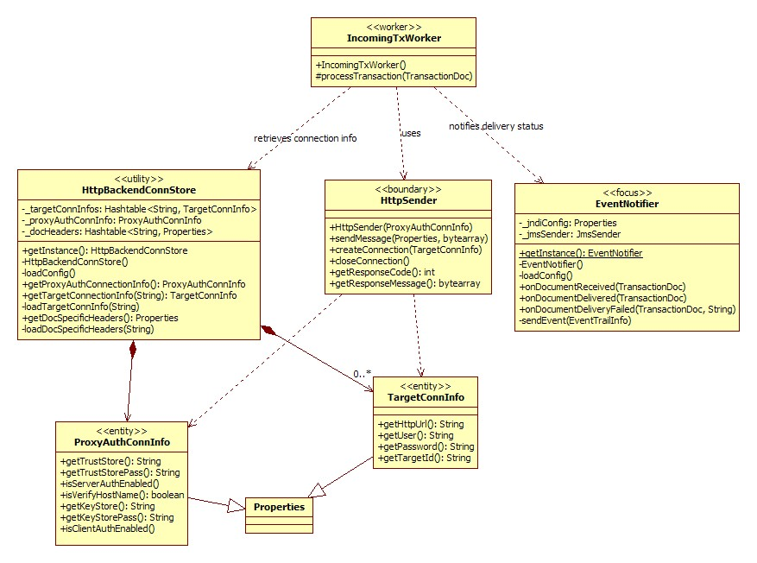
Figure 6: Class Participants in ISHB for Transaction Delivery to Backend

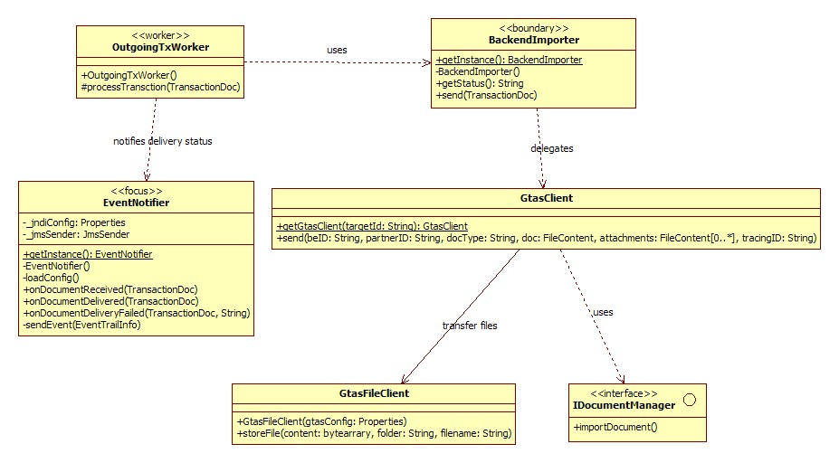
Figure 7: Class Participants in ISHB for Transaction Delivery to GTAS

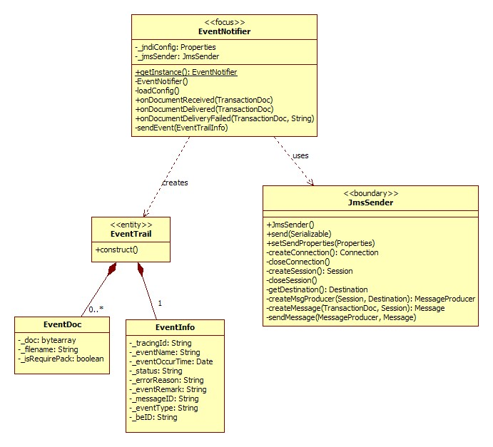
Figure 8: Class Participants in ISHB for Event Notification

Class / Package Descriptions

Module: HTTPBC

com.gridnode.gridtalk.httpbc.common
This package contains common classes that are used among the different components of HTTPBC.
com.gridnode.gridtalk.httpbc.common.util
This package contains utility classes that are used among the different components of HTTPBC.
EventNotifier | This is a utility class that handles sending of event notifications via JMS to the transaction monitoring module.
com.gridnode.gridtalk.httpbc.common.model
This package contains data model classes that are used among the different components of HTTPBC.
EventDoc | This acts as a data holder for a document file, similar to FileContent, but used for event notification.
EventInfo | This contains details above an event to be notified.
EventTrail | This holds information about an event to be notified and the document that needs to go along with the event.
FileContent | This acts as a data holder for a document file, including the byte contents and filename.
TransactionDoc | An instance of this holds the necessary information about a document that is received from the backend or trading partner, including tracing id, partner id, business entity id, document type, document and attachments contents, etc.
com.gridnode.gridtalk.httpbc.gthb
This package contains classes required for sending incoming transactions to ISHB.
AsyncBackendPush | This class is called from within the GTAS workflow engine during partner function. It is responsible for transforming a GridDocument to a TransactionDoc object and sending this object onto the TxInQueue via JmsSender.
com.gridnode.gridtalk.httpbc.ishc
This package contains classes required for receiving outgoing transactions from backend and sending those transactions to ISHB.
HttpBackendReceiveServlet | This is a HTTP Servlet that responses to HTTP requests from the backend. It delegates the processing of the request headers and contents to ReceiveDelegate.
ReceiveDelegate | This handles a transaction using some pre-defined required header properties and the transaction content. It constructs a TransactionDoc object out of the receive transaction content and header properties and calls up the ITransactionHandler to handle the TransactionDoc object.
com.gridnode.gridtalk.httpbc.ishb
This package contains the core classes for handling the received transactions and delivering the transactions to the target destinations.
TxDeliveryService | This handles delivery of transactions to the targeted destination. This service is made schedulable on regular intervals for each direction of delivery i.e. IN and OUT. On each execution of the service, transactions would be tried one at a time to be delivered if the delivery of the previous transaction is successful, for a certain maximum number of transactions. Once a transaction fails to be delivered, service would be stopped and waits for the next scheduled execution time.  A transaction is delivered using the ITransactionHandler operations: deliverIncomingTransaction() and deliverOutgoingTransaction().
com.gridnode.gridtalk.httpbc.ishb.ejb
This package contains the EJB classes for controlling the core processing of ISHB.
ITransactionHandler | This is the interface for TransactionHandlerBean.
TransactionHandlerBean | This is the implementation for ITransactionHandler.  When invoked on handleIncomingTransaction() and handleOutgoingTransaction() operations, it saves the TransactionDoc object via the TransactionDAO and sends an event notification on the successful receive of the transaction.  When invoked on deliverIncomingTransaction() and deliverOutgoingTransaction() operations, it creates the IncomingTxWorker and OutgoingTxWorker respectively to perform the delivery of the transaction to the designated destination.
SaveTransactionMDBean | This is a message driven bean that receives JMS messages from the TxInQueue. Each JMS message received is expected to be a TransactionDoc object, and contains a message property that indicates the direction that the transaction i.e. IN or OUT. Depending on the direction, it delegates the handling of the TransactionDoc object to the handleIncomingTransaction() or handleOutgoingTransaction() method of ITransactionHandler.
com.gridnode.gridtalk.httpbc.ishb.model
This package contains data model classes as well as data access objects.
TransactionDAO | This handles the data access operations for TxRec.  When a TransactionDoc is received, it needs to be persisted to the database. To do this, a TxRec object is created that wraps around the TransactionDoc and contains additional information about the transaction document. The TxRec is then inserted to the database.  During delivery, a TransactionDoc is retrieved from TxRec; if delivery is successful, the TxRec is removed from the database; otherwise the TxRec is updated with an incremented attempt count.
TxRec | This is an entity that represents a transaction that is received from either the trading partner or backend. The presence of such a record indicates that the transaction has not been delivered to its targeted destination.
com.gridnode.gridtalk.httpbc.ishb.senders
This package contains classes used for performing the delivery of transactions to target destinations.
BackendImporter | This handles delivery of transactions to GTAS by importing the document via the GTAS document manager.
GtasClient | This handles the interfacing between HTTPBC and GTAS.
GtasFileClient | This handles file accesses or transfers to GTAS file system.
HttpBackendConnStore | This is a utility class that provides the configurations that are required during the delivery for backend. These configurations include: trust store and keystore details for SSL connection, and connection details for target HTTP destinations.
HttpSender | This performs the HTTP connection to the target destination and sends over the transaction in a properly formatted HTTP request.
ProxyAuthConnInfo | This provides the trust store and keystore details that are required for SSL connection. Information may not be available if server authentication and client authentication are not required.
TargetConnInfo | This provides the connection details for a particular HTTP destination, including the HTTP URL, authentication credentials, etc.
com.gridnode.gridtalk.httpbc.ishb.workers
This package contains the classes that process the transactions for delivery.
IncomingTxWorker | This TransactionWorker delivers transactions intended for delivery to backend.
OutgoingTxWorker | This TransactionWorker delivers transactions intended for delivery to trading partners.
TransactionWorker | This is an abstract implementation for the IncomingTxWorker and OutgoingTxWorker. It provides common operations that are required during the delivery process.

Module: UTIL
com.gridnode.util.jms
JmsSender | This is a utility class that enables Serializable objects to be transmitted via JMS.

Module: GTAS.DOCUMENT
com.gridnode.gtas.server.document.facade.ejb
IDocumentManagerObj | This is a utility class that enables Serializable objects to be transmitted via JMS.

Interface Model
This section describes the interfacing requirements for HTTP between HTTPBC and customer backend.

Outgoing Connections from HTTPBC

HTTPBC would be using a HTTP/S Post method to establish an outgoing connection to backend systems via the URL provided by the customers. In the HTTP Request, the information would be transmitted in header and body as described below:
Method
HTTP/S POST

URL
Customer Backend URL

Request Headers

- DocType
This is the document type of the business document defined in GridTalk.
- SenderId
This is the partner id of the trading partner defined in GridTalk.
- RecipientId
This is the business entity id of the customer defined in GridTalk.
- DocFilename
This is the filename of the business document sending to customer.
- Additional headers (with fixed name and value) may be added per document type.
Request body
This refers to the business document payload.

In response to the HTTPBC request sent out, it expects a
- HTTP response code 200 or 202 for successful send.
- Any other HTTP response code will be deemed as unsuccessful connection.

Example

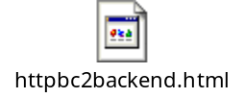

Incoming Connections to HTTPBC

HTTPBC would be expecting the customer backend to send the payload to the URL via HTTP/S Post Method. The incoming HTTP/S requests are expected to be in the format as shown below:

Method
HTTP/S POST

URL
GridTalk backend connector URL:
http://<public_url>/gridtalk/van/httpbc/receive
https://<public_url>/gridtalk/van/httpbc/receive

Request Headers
It is important to note that the request header names as stated below are case-sensitive.
- doctype
This is the document type for the business document when it goes into GridTalk.
- sender
This is the business entity id of the sending customer, as defined in GridTalk.
- recipient
This is the partner id of the receiving trading partner, as defined in GridTalk
- filename
This is the filename of the business document when it goes into GridTalk.
Header 'filename' is optional, the rest are mandatory.

Request body
This refers to the business document payload.

In response to the request, HTTPBC will return
- HTTP response code 202 if request can be interpreted correctly and saved in database.
- HTTP response code 400 if any of the mandatory headers are missing from the request.

Example

